Stream Operations
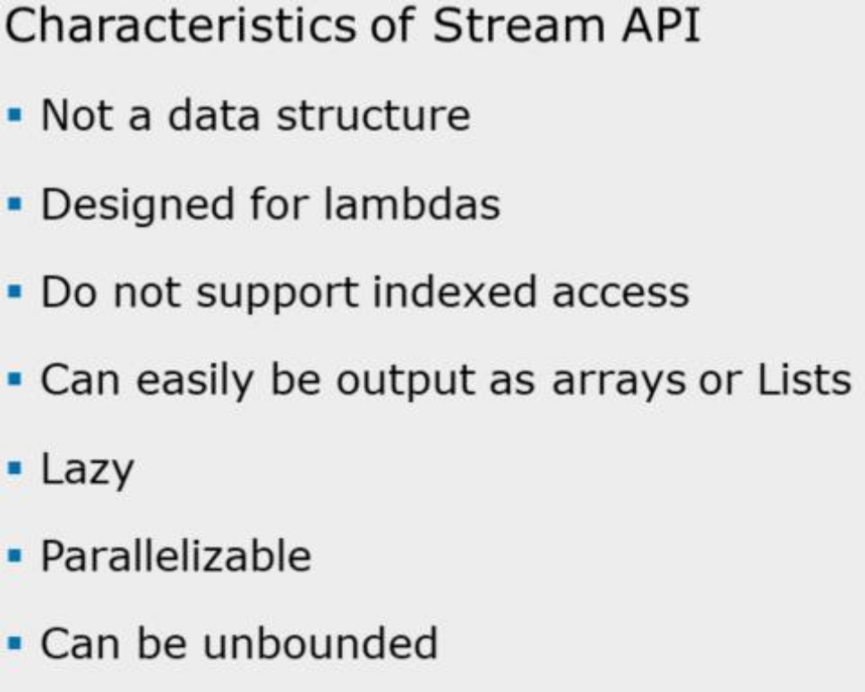

Lazy:
Many Stream operations are postponed until it is known how much data is eventually needed E.g., if you do a 10-second-per-item operation on a 100 element list, then select the first entry, it takes 10 seconds, not 1000 seconds.
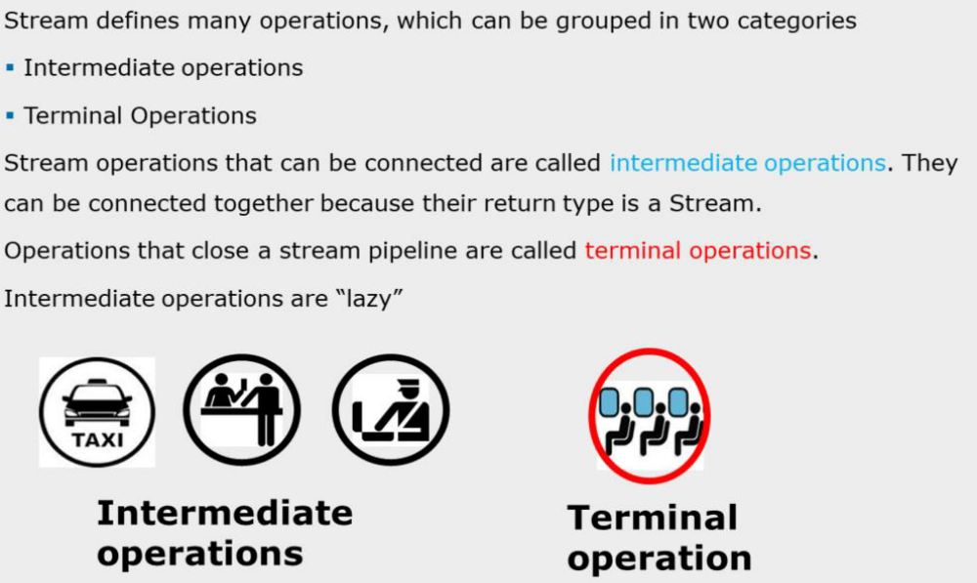

== Intermediate operations do not perform any processing until a terminal operation is invoked on the stream pipeline.

Working with Stream:

Step-1:

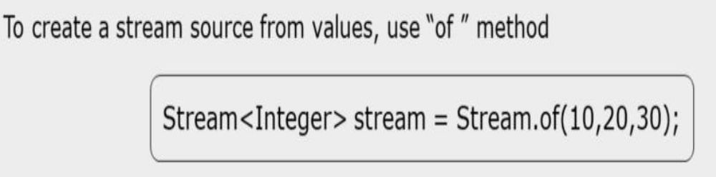

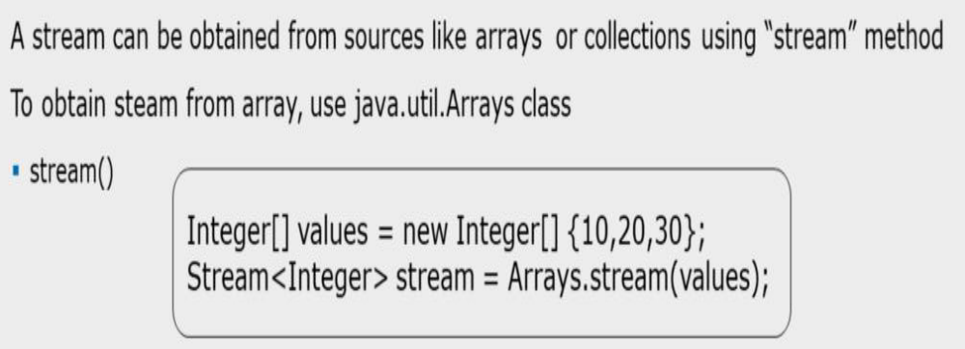

Step-2:

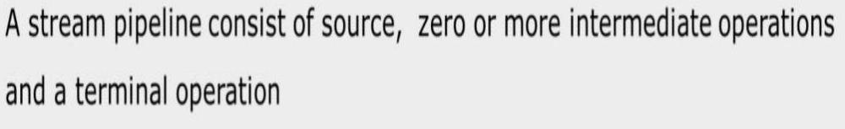

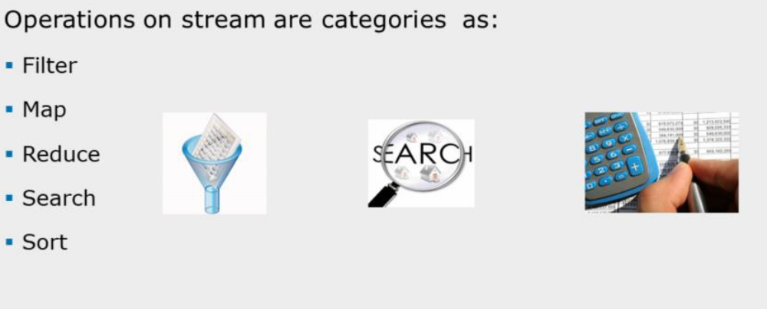
Steam Operations are : MRFSS

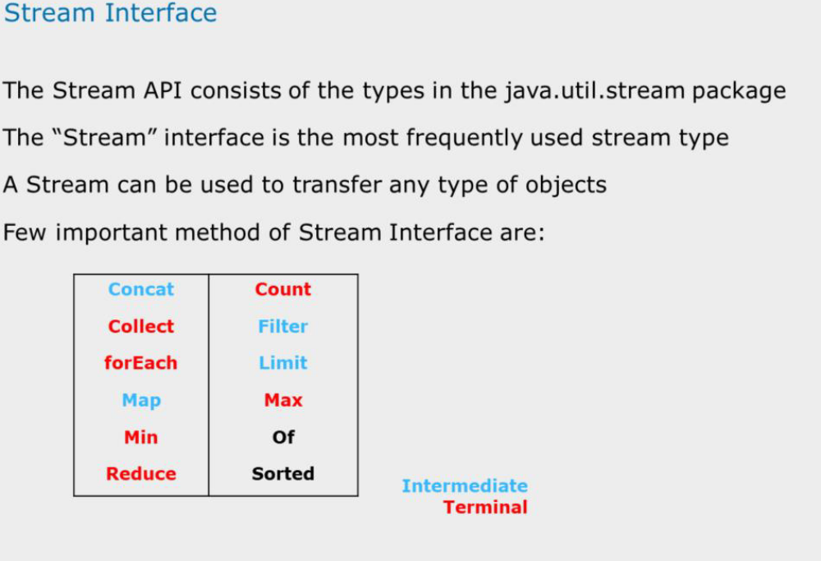

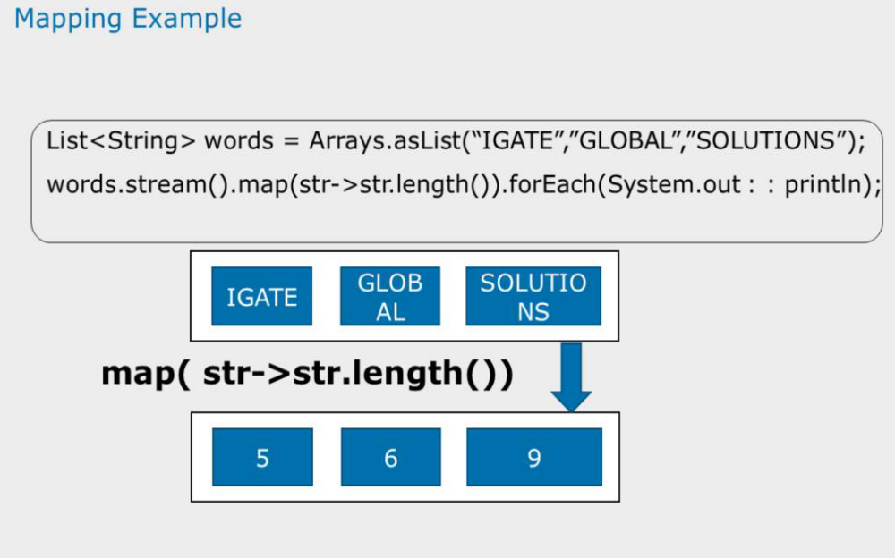
Note:

After any intermediate operation on stream, the processed items in resultant stream can be collected in separate collection if required.

List<String> words = Arrays.asList("IGATE","GLOBAL","SOLUTIONS");
List<Integer> counts = words.stream()
.map(str->str.length())
.collect(Collectors.toList());

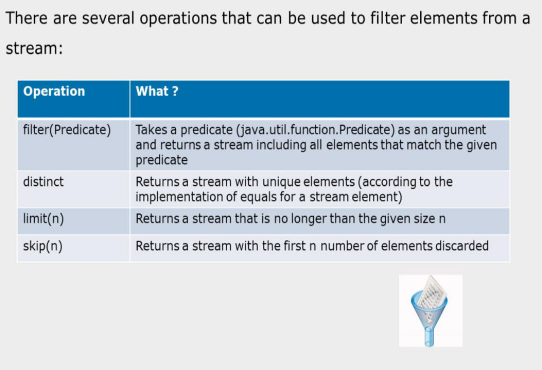
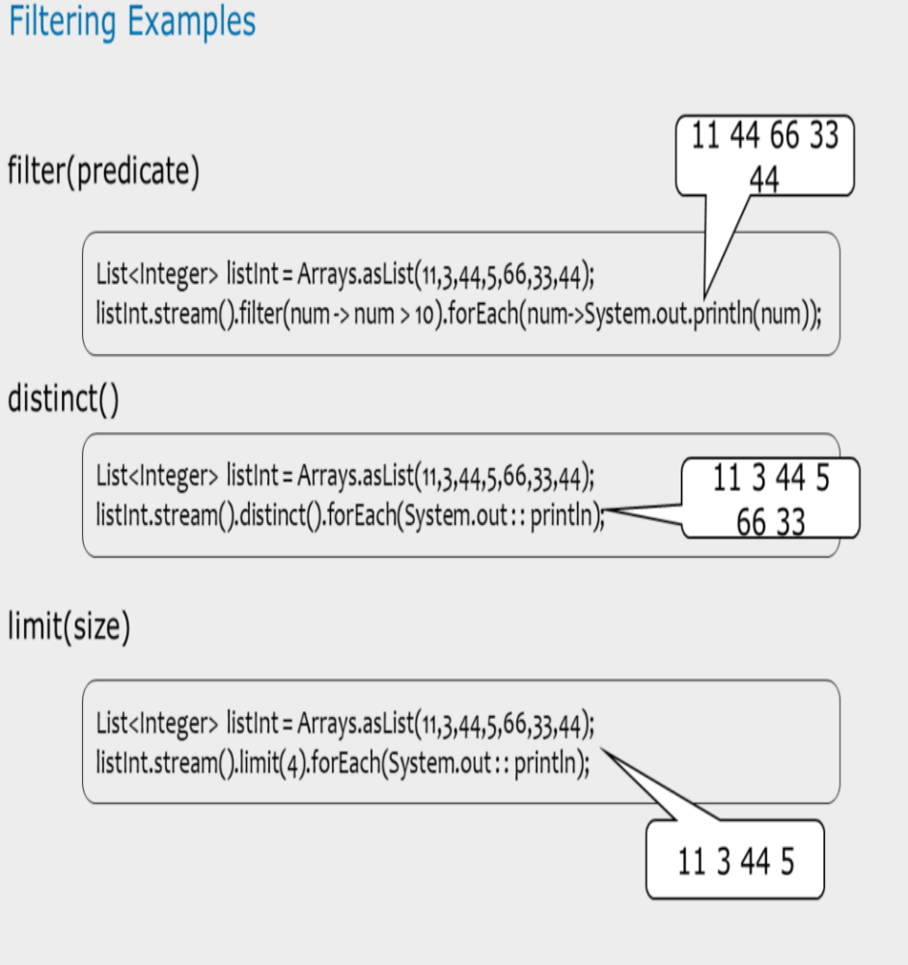

The distinct() method removes duplicate from the stream.
